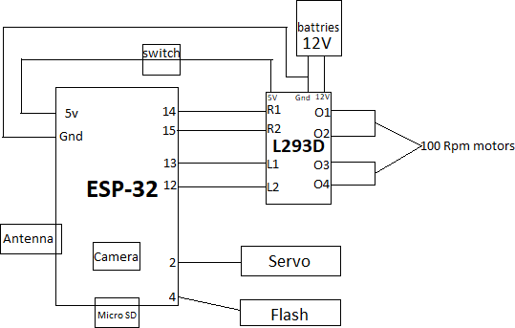

**Fig 1: *Block Diagram of Surveillance Robot***

*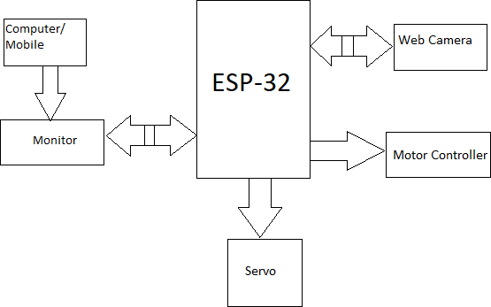*

Fig 2: Manual Automatic Operation

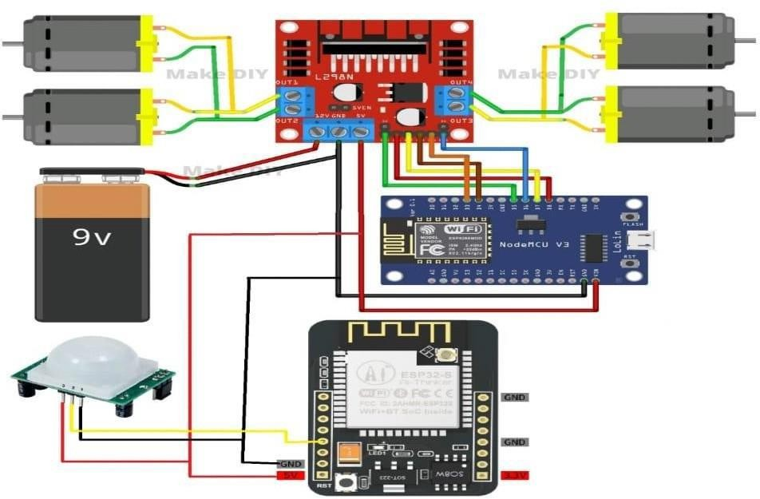

**Fig 3: Connections of *Surveillance Robot***



IntelliScout Ver 2: High-Precision Autonomous Spybot with Live Camera and Radar for Efficient Surveillance

(Dhruv Dhayal & Pratham Aggarwal)